**Lesson 1: Introduction to HTML**

**Lesson 2: Text Formatting and Structure**

**Headings and paragraphs**

HTML provides six levels of **headings, <h1> to <h6>, with <h1>** being the highest level and <h6> the lowest. Headings are used to structure the content and indicate its hierarchy on the webpage

**Paragraphs** are created using the <p> tag. Text placed between <p> and </p> tags is treated as a separate paragraph.

**Comments in HTML**

<!-- --> - HTML comments are used to add notes or explanations within the HTML code that are not displayed in the browser. They are useful for documenting your code or temporarily hiding sections during development.

**Naming Convention**

ID **–** specific id of each elements (should be no duplication)

Name – specific name of elements, (possible for duplication)

Class **–** group of elements

**Text formatting tags (bold, italic, underline)**

<strong> **-** This tag is used to give text strong importance or emphasis, typically displayed as bold. (<b>)

<em> - This tag represents emphasized text, usually displayed as italic. (<i>)

<u> - This tag underlines the enclosed text.

<s> - This tag strikes through the enclosed text, indicating that it is no longer relevant or valid.

**Line breaks and horizontal rules**

<br> - This tag inserts a line break within a paragraph, allowing text or elements to appear on a new line.

<hr> - This tag creates a horizontal rule, a visible line that can be used to separate different sections of content.

&nbsp; – use to have a white space.

**Lists (ordered and unordered)**

<ul> and <ol>

<ul> - is used to create an unordered (bullet) list, while

<ol> - is used for an ordered (numbered) list.

<li> - This tag defines individual items within a list. Each list item is placed between <li> and </li> tags.

**Element Grouping**

<div> - This tag defines a division or section of the webpage, allowing you to group and style related elements.

<span> - This tag is an inline element used to apply styles to specific portions of text or elements within a paragraph.

**Block vs Inline ELEMENTS**

BLOCK - always starts on a new line, and the browsers automatically add some space (a margin) before and after the element.

**Examples:**

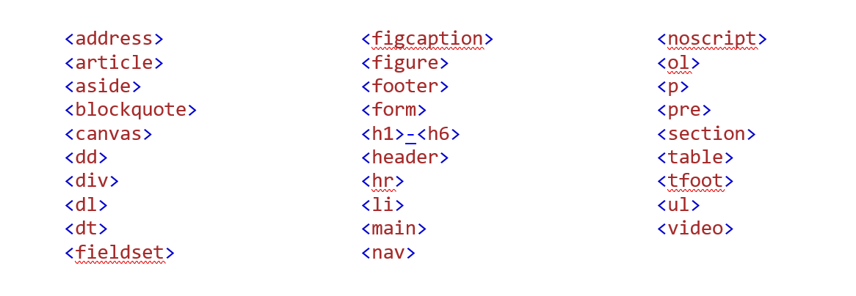

Inline - An inline element does not start on a new line and only takes up as much width as necessary.

**Examples:**

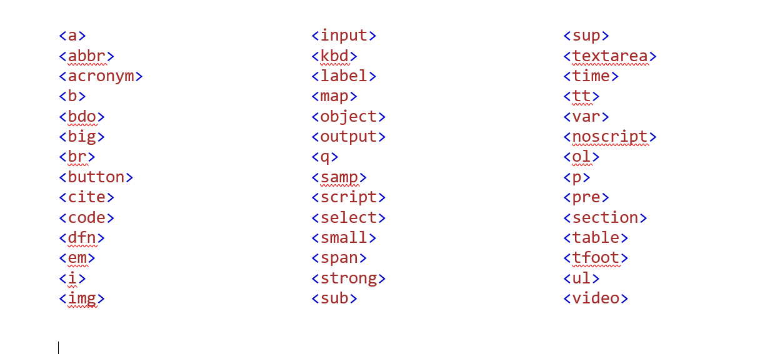

**Lesson 3: Anchors / links**

**Creating hyperlinks**

<a> - The anchor tag is used to create hyperlinks in HTML. It requires an href attribute that specifies the URL of the target webpage or resource. The content between the opening and closing <a> tags serves as the clickable text or image for the link.

**Linking to external websites**

To create a link to an external website, provide the full URL within the href attribute of the anchor tag. For example: **<a href="https://www.example.com">Visit Example</a>**

**Linking to different sections within the same page**

HTML allows you to create internal links within the same page using anchor tags and the id attribute. Assign an id to the target element you want to link to, and then use the href attribute with a preceding # symbol to specify the target element's id. For example: <a href="#section2">Go to Section 2</a>.

**Opening links in a new tab or window:**

You can add the target attribute to an anchor tag and set it **to _blank** to open the link in a new browser tab or window. For example: <a href="https://www.example.com" target="_blank">Visit Example</a>.

**Lesson 4: Images and Multimedia**

**Image formats**

Common image formats supported in HTML include JPEG, PNG, and GIF. JPEG is suitable for photographs, PNG for images with transparency or sharp edges, and GIF for simple animations.

**Adding images to a webpage**

<img> - The image tag is used to insert images into an HTML document. It requires the src attribute, which specifies the path or URL to the image file. For example: <img src="image.jpg" alt="Description of the image">

**Image attributes (size, alignment, alt text)**

width and height attributes - These attributes define the width and height of the image in pixels. Specifying the dimensions helps browsers allocate space for the image before it loads.

align attribute - This attribute specifies the alignment of the image within the surrounding text. Common values include "left", "right", .

alt attribute - As mentioned earlier, the alt attribute provides alternative text for the image.

**Embedding videos and audio:**

<video> - The video tag is used to embed videos on a webpage. It supports various attributes like src (the video file URL), controls (displays video controls), width, height, and more.

<audio> - The audio tag is used to embed audio files. It also supports attributes such as src, controls, autoplay, and loop.

**ACTIVITY: CREATE A BIO-DATA PAGE**

**Lesson 5: Table**

Tables in HTML are created using the <table> tag. Within the table element, you define rows using the <tr> tag and columns using the <td> tag.

**Adding rows and columns**

To add a new row to a table, use the <tr> tag and include the desired number of cells (<td>) within it. Each cell represents a column in the table.

To add additional columns to an existing row, simply add more <td> elements within the corresponding <tr>.

**Table headers and body**

<th>: The table header tag is used to define header cells within the <thead> section of a table. Header cells are typically displayed in bold and centered by default.

<caption>: The caption tag is used to add a caption or title to a table. It is placed immediately after the opening <table> tag and before the <thead> or <tbody> section.

**Formatting table elements**

Attributes such as colspan and rowspan can be added to table cells (<td> or <th>) to span multiple columns or rows, respectively.

**Lesson 6: Forms and User Input**

**Form structure and elements**

<form> - The form tag is used to create an interactive form on a webpage. It contains various form elements that allow users to input data.

<input> - The input tag is the most commonly used form element. It provides a wide range of input types, including text fields, checkboxes, radio buttons, and more.

**Form fields**

Text fields - <input type="text"> creates a single-line text input field

Password fields - <input type="password"> creates a text input field where the entered text is masked (useful for password inputs).

Checkboxes - <input type="checkbox"> allows users to select multiple options.

Radio buttons - <input type="radio"> allows users to select a single option from a group of choices.

Dropdown menus - <select> with <option> creates a dropdown menu for selecting a single option from a list.

Text areas - <textarea> creates a multi-line text input field for longer text entries.

**Form accessibility**

Ensuring form accessibility involves providing appropriate labels for form elements using the <label> tag. Labels can be associated with input elements using the for attribute or by nesting the input element within the label element.

**Submitting forms and handling data**

<button>: The button tag is used to create a submit button within a form. It triggers the submission of form data to the server.

**Readonly and Hidden**

**Readonly / disabled** – the readonly is use to make an input element uneditable

**Hidden** – it is use to make element hidden

**Value** – use to set the value

**Selected** – Default select

**Form validation and error messages**

HTML5 introduces built-in form validation using attributes like, **required**, **min**, **max**, and more. These attributes help enforce data entry rules and provide automatic validation feedback.

**Lesson 7: Semantic HTML**

Semantic HTML refers to using HTML elements that carry meaning and provide context to the content they enclose. By using semantic elements, you can enhance the structure and accessibility of your web pages.

**Common semantic HTML elements**

<nav> - The nav tag is used to define a section containing navigation links.

<main> - This tag represents the main content of a webpage, excluding headers, footers, and navigation

<footer>: This tag represents the footer of a document or a section, typically containing information about the author, copyright notice, or contact details.

**8. HTML5 Advanced Features**

**New input types and attributes**

<input type="date"> - Allows users to select a date from a calendar widget.

<input type="email"> - Validates email addresses

<input type="color"> - Enables color selection through a color picker.

<input type="range"> - Creates a slider control for selecting a value within a specified range.

**ACTIVITY: MAKE AN ORDER MENU**